**Risk Assessment**

Submitted By:

Group - 3

Jai Patel - 301170222

Najmun Nahar – 301160081

Abhishake Malhotra – 301177229

Course: COMP377-001

Instructor: Arindam Das

Submission Date: 12th December,2022

**Front-end Libraries:**

* **React** - <https://reactjs.org/>
* **Bootstrap** - <https://getbootstrap.com/>
* **Axios** - <https://www.npmjs.com/package/axios>

**Backend Libraries**

* **Flask** - <https://flask.palletsprojects.com/>
* **Scikit-learn -** <https://scikit-learn.org/stable/>

**User Guide:**

**pip install flask** if there is none.

1. Using Vs Code Run the backend of the app.
   1. **cd app**
   2. **Run the backend using command python api.py**

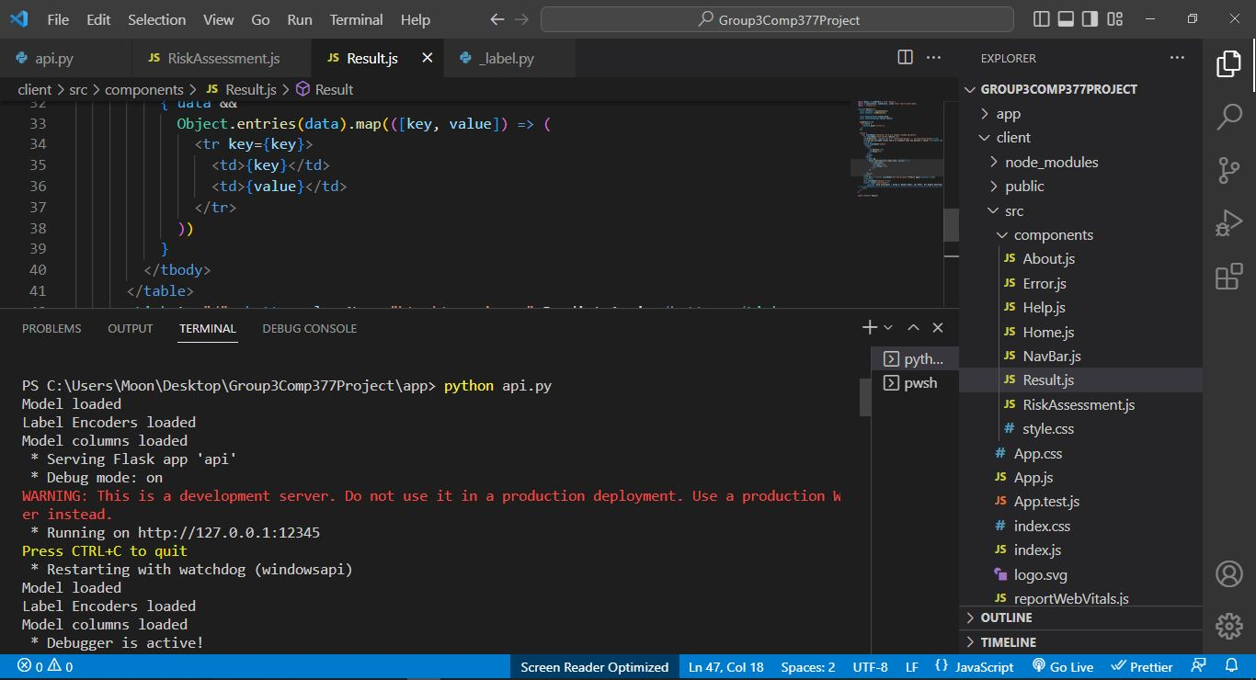

1. For User interface, run client
   1. **cd client**
   2. **npm install**
   3. **npm start – to run the project. The result will be visible at “localhost:3000” port.**

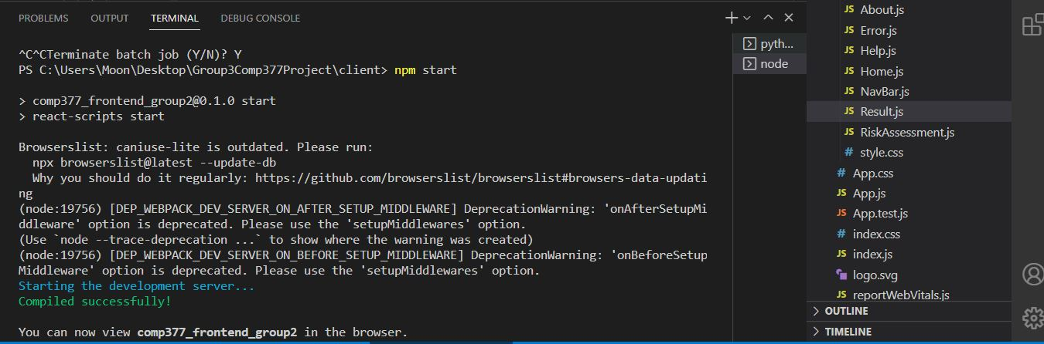

**Screenshots:**

**1. Home – User can get started from the Home page. It gives a short description about the project.**

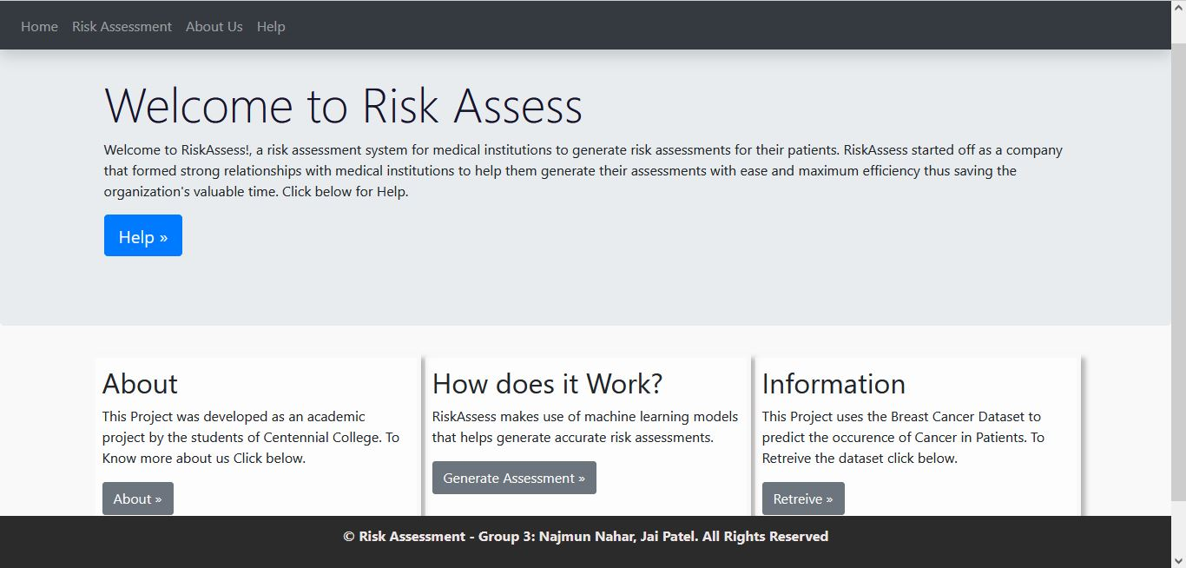

**2. About us – Introduces the Team members**

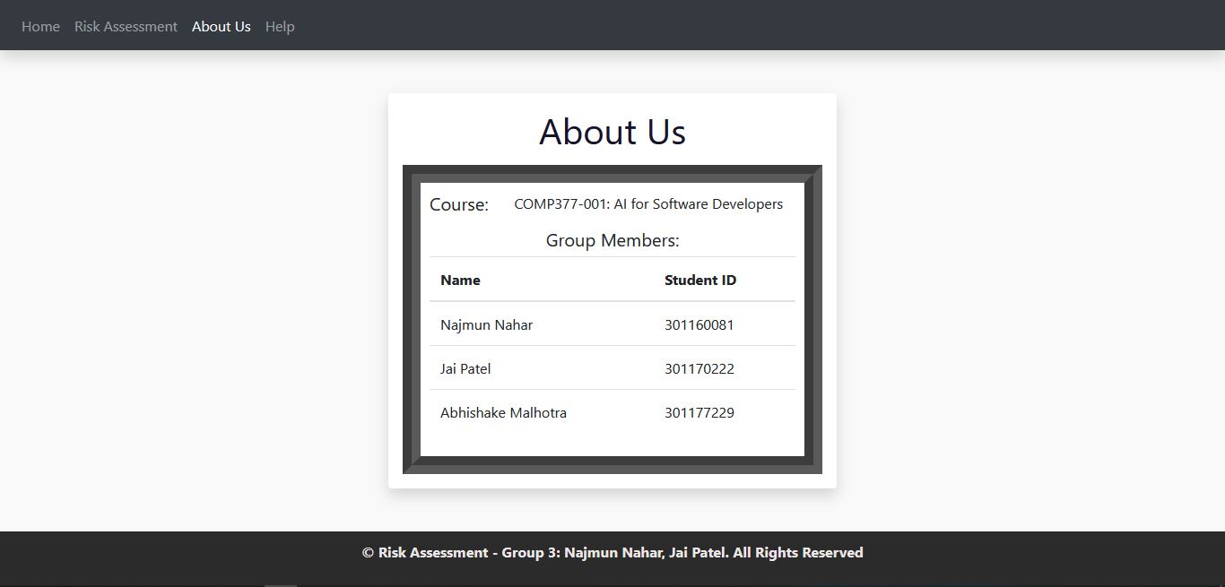

**3. Help – Helps the user with providing basic instructions on how to use the system.**

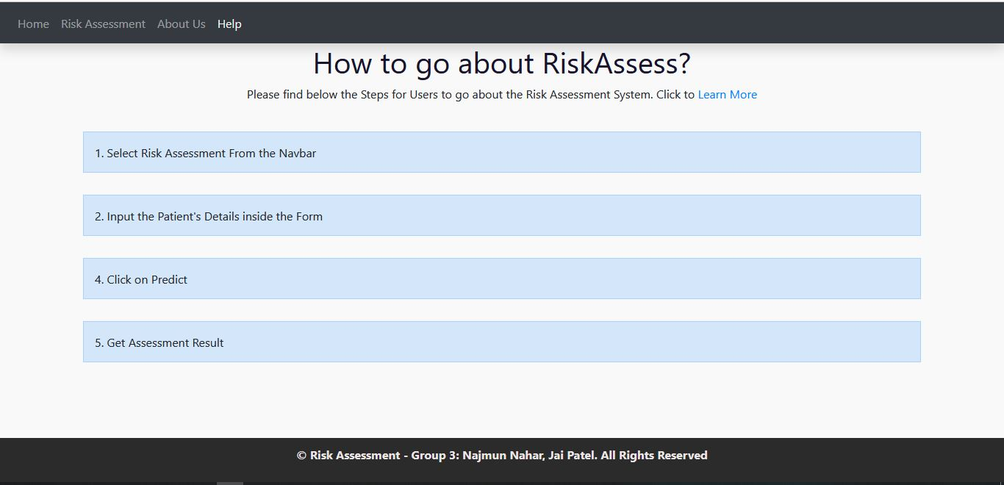

**4. Risk Assessment Form – User can enter patient details into the input form.**

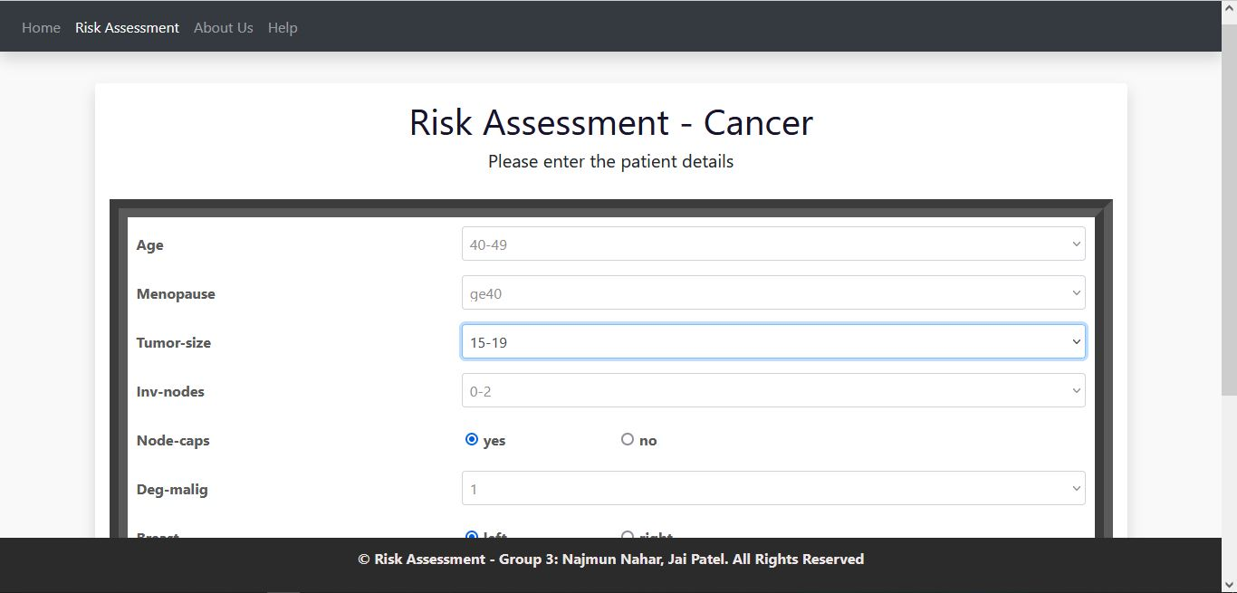

**5. Result Page- Displays Predicted result of whether the patient is at risk of getting Cancer back.**

